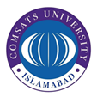
COMSATS University Islamabad
Graduate Office
Department of Management Sciences
Park Road, Tarlai Kalan, Islamabad. Tel: +92-051-90496071
December 18, 2019
Certificate for Incorporation of Changes

This is to certify that Mr. Abdul Qayyum bearing Registration No. CIIT/SP12-PMS-001/ISB has incorporated all the changes as recommended by the local/foreign examiners.

Prof. Dr. Khalid Riaz  Supervisor | Dr. Osman Sadiq Paracha  In-charge, (Management Sciences)

